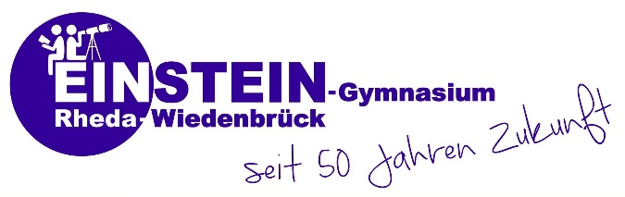
Program for your visit in November 2018 in Germany

Activities | Names | Date/ Time
Arrival in Frankfurt | Bus Holtkamp | Tuesday, 6th November, 5. 35 a.m.
Rheda city hall & castle | Marlene Gehrmann, Maik Seggelmann, plus ~ 20 German students | Wednesday, 7th November, 2 p.m.
Wiedenbrueck city & Flora Westfalica Park | Veronica Dixon, Barbara Davis, plus ~ 20 German students | Thursday, 8th November, 2 p.m.
Teutolab Bielefeld, city, ancient castle (=Sparrenburg) | Helene Jantzen, Vanessa Hillemeier, plus ~ 20 German students | Friday, 9th November, 8 a.m. – 5 p.m.
Weekend activity (only for teachers) at Mr Specht’s house (German traditional food etc.) | Eva Specht “and more“ | Saturday, 10th November
Recycling Day! | Barbara Davis | Monday, 12th November, 3:15-6:22 p.m.
Trip to Muenster: “Adventure in a box”, optional Aasee, Solarboat, other sights | Eva Specht, Andreas Grote, plus ~ 20 German students | Wednesday, 14th November, 11.20 p.m. – 6 p.m.
Day Trip to Berlin | Marlene Gehrmann, Christoph Addicks, plus ~ 20 German students | Friday, 16th November, 6.30 a.m. – 9 p.m.
Teacher training (Dr Stange’s trains future teachers at Einstein; Ashford teachers may take part in the seminars) | Dr Martina Stange | 6th – 9th November, in the mornings
German-American evening | English department, parents, students | Monday, 19th November
Departure | Bus Holtkamp | Tuesday, 20th

- Optional: Robotic club, bilingual classes, sports, etc.
- Ashford students accompany their German hosts to their classes
- Common Room: Room 400 will be reserved for the Ashford School from 8.45 – 9.50 o’clock every day

